**YAML** - «дружественный» формат [сериализации](https://ru.wikipedia.org/wiki/%D0%A1%D0%B5%D1%80%D0%B8%D0%B0%D0%BB%D0%B8%D0%B7%D0%B0%D1%86%D0%B8%D1%8F) [данных](https://ru.wikipedia.org/wiki/%D0%94%D0%B0%D0%BD%D0%BD%D1%8B%D0%B5) – XML, JSON, концептуально близкий к [языкам разметки](https://ru.wikipedia.org/wiki/%D0%AF%D0%B7%D1%8B%D0%BA_%D1%80%D0%B0%D0%B7%D0%BC%D0%B5%D1%82%D0%BA%D0%B8) - XML, но ориентированный на удобство [ввода-вывода](https://ru.wikipedia.org/wiki/%D0%92%D0%B2%D0%BE%D0%B4-%D0%B2%D1%8B%D0%B2%D0%BE%D0%B4) типичных [структур данных](https://ru.wikipedia.org/wiki/%D0%A1%D1%82%D1%80%D1%83%D0%BA%D1%82%D1%83%D1%80%D1%8B_%D0%B4%D0%B0%D0%BD%D0%BD%D1%8B%D1%85) многих [языков программирования](https://ru.wikipedia.org/wiki/%D0%AF%D0%B7%D1%8B%D0%BA_%D0%BF%D1%80%D0%BE%D0%B3%D1%80%D0%B0%D0%BC%D0%BC%D0%B8%D1%80%D0%BE%D0%B2%D0%B0%D0%BD%D0%B8%D1%8F).

В основном используется для конфигурации. В docker используется для docker-compose

Можно создать YAML файл с двумя форматами:

* .yaml
* .yml

**YAML**  **XML**  **JSON**

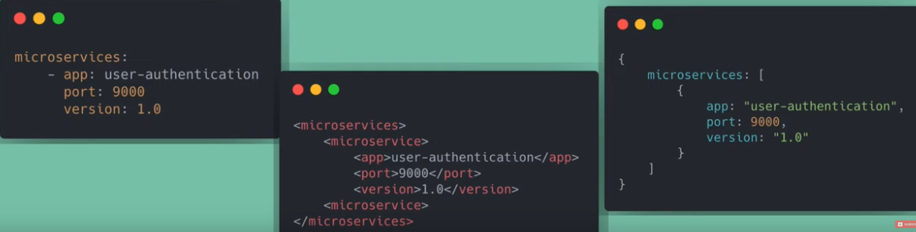

Any valid JSON file is also a valid YAML file

YAML uses line separations and spaces for validation. When XML uses tags and JSON uses {}, []

YAML uses **key**: **value** pairs. Values can be quoted or unquoted

Comments can be done via **# comment**

We can **create objects** by nesting attributes inside the key: value pair. Microservice is an object with app, port, version attributes

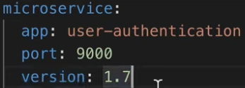

We can **create lists** by using **–** sign. Note that other attributes must have the same indentation. We can either have **–** sign for each attribute, like for versions. Or for objects. We can also use [] for simple list attributes, like for versions

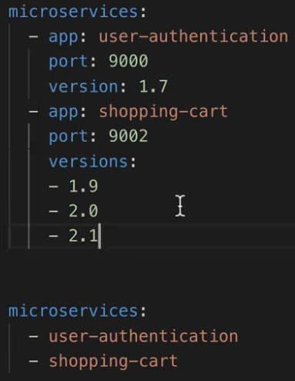

We can have **Boolean** values. Key: **true/false/yes/no**

**Multiline strings**. If we have a multiline string and we want it to be shown the same as written, we can use **|** sign

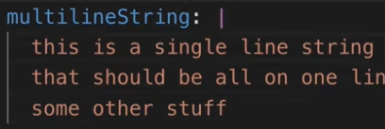

If we have a **multiline string** and we want it to be shown in 1 line, we can use **>** sign

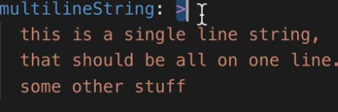

We can have **environmental variable**. We access it by using **$**variable_name sign

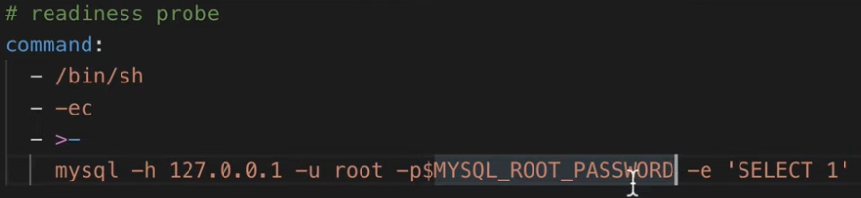

We can have **placeholders**. We use **{}** for that

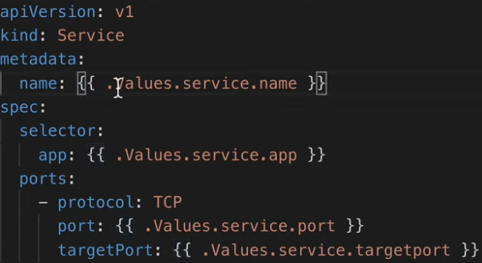

We can group multiple YAML files inside one file using **---** sign between those files

